It is with sadness that we announce the passing of
Peter John Reed
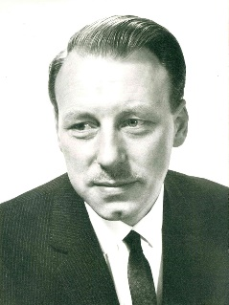
Following a private cremation attended by family only
You are all invited to join us at a
Thanksgiving Service
to celebrate his life
at
12 noon, Friday 26th October
at
St John’s Church, Eastbourne Road (A22), Blindley Heath, Lingfield, RH7 6JH.
and afterwards at a
Funeral Reception
at
Yew Lodge Country House, Felcourt Road, East Grinstead, RH19 2JX.

Donations in lieu of flowers to Dementia UK
either by donating on his tribute page at https://peter-reed.muchloved.com/
or post to c/o Alex Jones Funeral Directors, 1 East Grinstead Road, Lingfield, RH7 6EP.

From his daughters
Sue Kent, 07957 453303 or sue.kent@talk21.com
Alison Sandham, 07811 035811 or alison.sandham@gmail.com

